Islamic Civilization
Student Name
Institution Affiliation

Islamic Civilization
Introduction
This essay entails civilization in the middles east region of Asia. The area consists of Iraq, Iran, Saudi Arabia, Syria, Israel, and Egypt among others (Adams, 2018). Islam is the main religion in the Middle East region. The region is characterized by immense oil production and exports to the rest of the world. A specific focus in the paper is drawn with regard to the religion, its teachings, and growth in the region. Trade and literature are also discussed elaborately.
Islam in the Middle East
Islam is the main religion in this region. Statistics state that over 20% of the global Muslim population stays in the Middles East. The religion is monotheistic in nature in that it ascribes to only one supernatural being referred to as Allah. Their holy book is called the Quran which houses all the Islamic teachings.
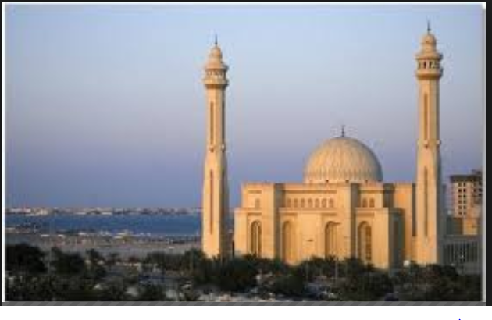
Figure 1: A photo of a mosque in Saudi Arabia
Source: khanacademy.org
The spread of Islam in the Middle East took a short period because it was via the means of the sword after Mohamed’s death in 632. In fact, the Arabian Desert was the beginning point of the spread of Islam to the other global areas like North Africa, Iberia, Spain, Portugal, and other areas. The Byzantine Christianity that thrived in the region seemed weak (Adams, 2018). As a result, it was overthrown by the fierce Muslim missionaries. Currently, Islam occupies the second place in terms of the largest religions in the world. It is subdivided into Shia and Sunni affiliations. The latter is larger than the former.
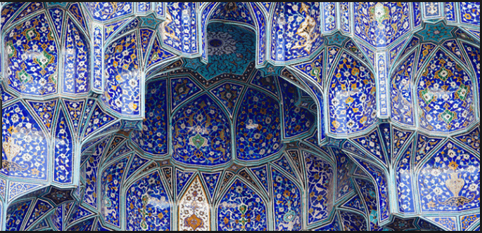
Figure 2: a photo showing a successful field for Islam financing
Source: https://fundit.hypotheses.org/325
The main teachings of Muslims are that there is no other God but Allah with Mohamed as his prophet and last messenger. Other teachings of the Islam faith are that God is merciful, unique and all powerful. Islam also teaches about the final judgment of both adherents and non-adherents. The faithful’s will go to paradise and the unfaithful to hell. Moreover, Islam teaches it teaches about living right for them to attract Allah’s blessings.
Middle East Art
The main art and literature of the Middle East are related to Islam. It is not easy to characterize this art form as it covers wide areas like embroidery, carpets, Islamic pottery, glass, Islamic miniature, calligraphy, and architecture. Islamic art is in most cases characterized by repetitive motifs like vegetal and geometrical designs in an arabesque repetition. This kind of repetition is utilized in symbolizing the infinite, indivisible and transcendent God’s nature. Mistakes in the recurrent art may be deliberately made by the artists to indicating their imperfections and citing God as the only perfect being.
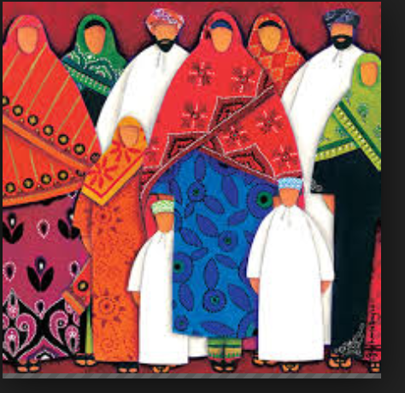
Figure 3: Middle East Islamic dressing code
Trade
The majority of the inhabitants of the Middle East are Arabs who have been traders since ancient times. They mainly trade and export oil. Arabs have also been participating in international trade in the past, particularly in the East Coast of Africa. They did this as they spread their religion to the native Africans (Adams, 2018.) It is estimated that over 40% of the global oil supply comes from the middles east. The current amount of shipments in the region amounts to over $325 billion. Middle East countries like Iran, Kuwait, UAE, Saudi Arabia, and Iraq make up the main crude oil exporters globally.

Conclusion
The Middle East block has been one of the successful global regions due to oil trade. Islam is the main religion. It teaches that Allah is the only God and Mohamed his only prophet. Most of the architectural designs from the region draw their designs from the Islam religion. Islam has greatly contributed to people’s civilization in the Middle East.
References
Adams, R. E. (2018). Ancient civilizations of the New World. Routledge.
Cleveland, W. L. (2018). A history of the modern Middle East. Routledge.

